Design and Development Document – Matthew Stewart – B01032816

To kick start the design and development process for this Zoo Management System that I have been tasked with designing. I have created a UML diagram which acts as the blueprints for me. Including classes like Zoo, Main and the Animal class. With me constantly referring to it if I get confused when programming the system. Displaying variables and methods that I will include in the program. This UML diagram also helps me with adding encapsulation to with the likes of the “+” or “- “to the very left of variable and methods. Which allows me to see what variables and methods are public or private. When implemented into the design, it does indeed allow us to achieve encapsulation and keeping private variables safe while out ruling errors.
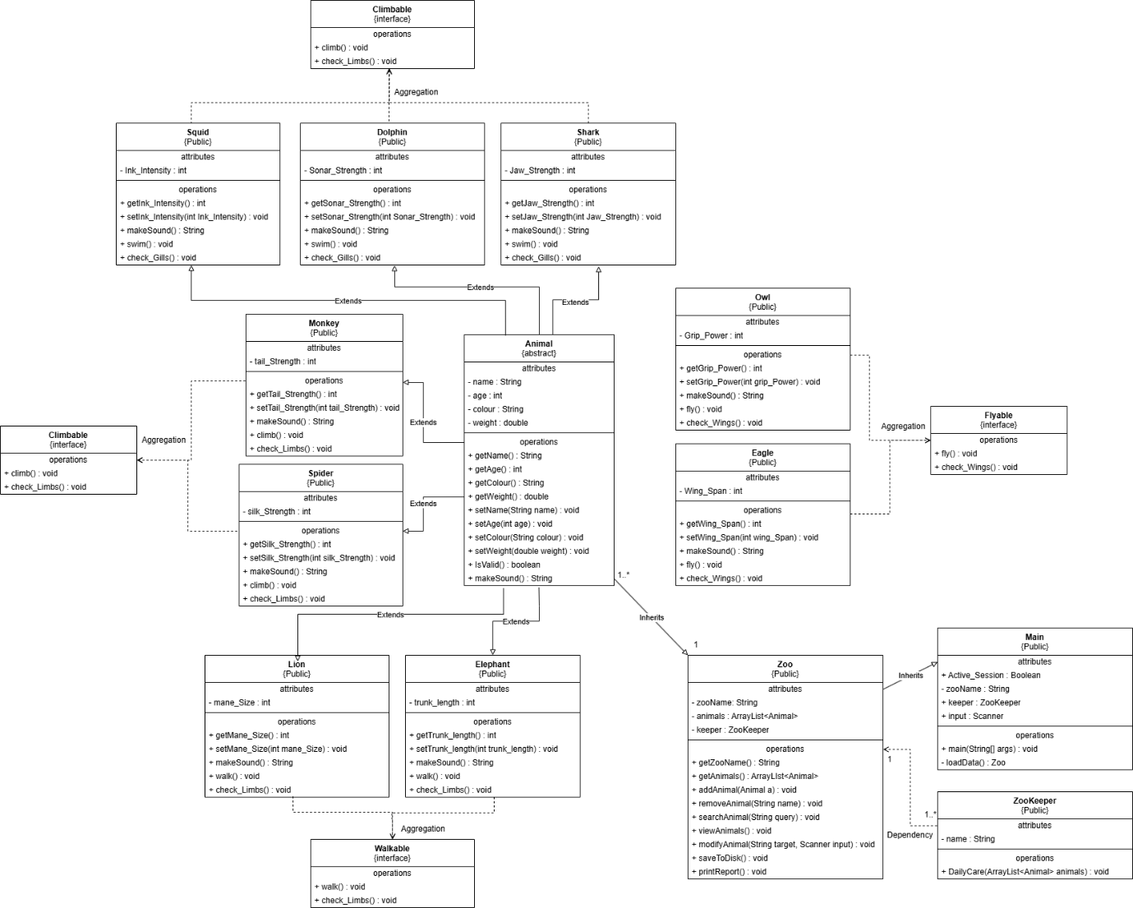
Along with the UML diagram I have also created a UML hierarchical design diagram, allowing me to better understand how the Zoo Management System that I am creating is going to function hierarchically. It also lets me see with the UML design diagram what methods and functions will be limited to or accessible too. Providing usability. Saving me time and stopping redundant methods from being created.
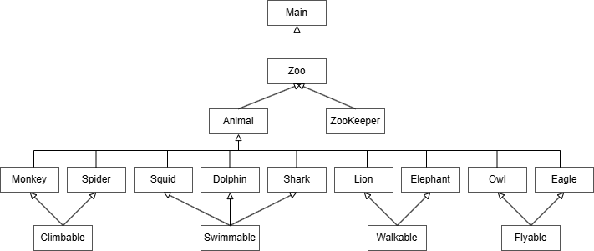
I have used polymorphism in the likes of method overloading in the Animal class that I have developed for the program. Such method overloading included is the makeSound() method. Used within the animals, such examples include the Lion or the Dolphin where when called, uses the function in the Animal class and overrides it with the specific animal sound. Another thing that is included and demonstrates polymorphism would have to be the ArrayList. With the ArrayList<Animal> using Animal it allows it to inherit from all animal classes like Lion, Eagle and Shark; it allows us to override methods within the animal classes without requiring knowing the specific animal. Saving us time and allowing the code to be simple and clean.
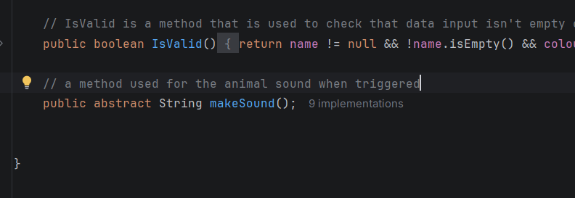

Moving onto data structures. A form of data structure that I have included as well as within the polymorphism is again the ArrayList, as it allows me and anything using the system to add in the animals without having to set a maximum or minimum on what the ArrayList can hold. Keeping exceptions like ArrayIndexOutOfBoundsException at bay, differing it from Arrays. It also comes with some functions prebuild such as add() or remove(). allowing us to quickly add our animals into the ArrayList without any thus.
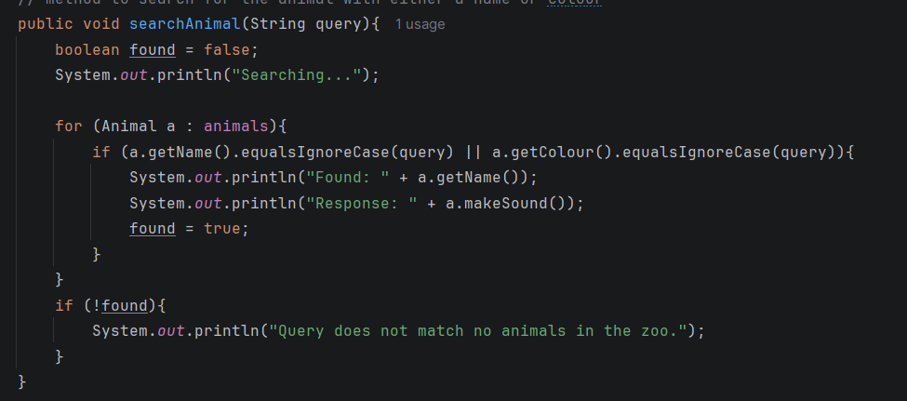
Finally with the program control structure. The three most used control structures that I have included within this program would have to be the for loop, if statements and switch. With firstly the for loop being the most important. When used with the ArrayList<Animal> it allows us to linear or sequence search for a specific animal when we use the modify or search for animal method. This is effective as it minimises errors within the code like IndexOutOfBoundsException, grabbing information that doesn’t exist. I have used both switch and if statements to cause certain events to trigger upon certain conditions. Such as with the switch statement. Which I have used in the Main Class which hosts the menu that the user will operate. Providing functionality based on what option the User chooses. The reason to why I didn’t choose an If statement is that they can be unreadable and their conditions can be long. Finally, a control structure I’ve include is the try-catch block, stopping errors from occurring from inputs or from methods and providing a clean and safe system. Overall, with the help of this document, it has allowed me to create a high-quality system.
